Part 1)

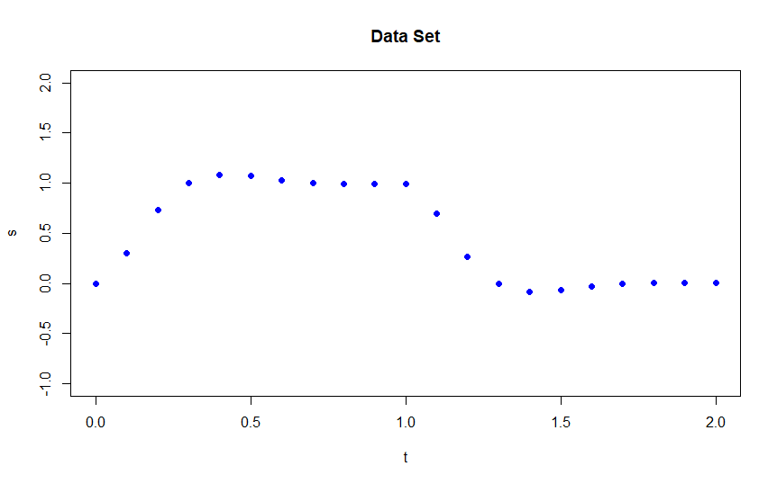

Part 2)

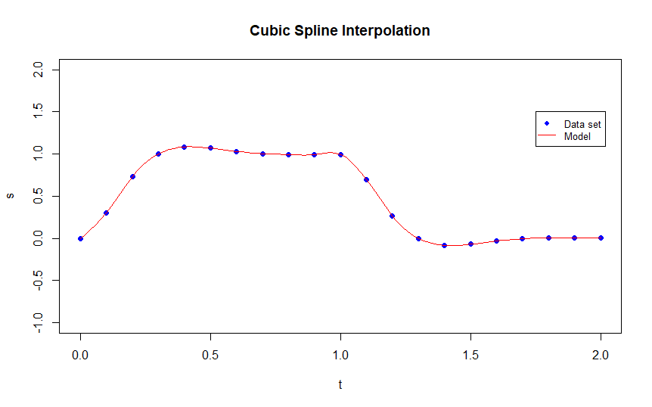

Part 3)

For the cubic spline interpolation model, at t=1.45 the prediction is f(1.45) = -0.08404